A Final Project Report on

**Remote Shell Executor over TCP**

Submitted in Partial Fulfillment of the Requirements for

The Degree of **Bachelor of Engineering in Information Technology** Under Pokhara University

Submitted by:

**Prakash Mahara, 211527**

**Roshan KC, 211435**

**Shushil Mishra, 211440**

Date:

22/07/2025

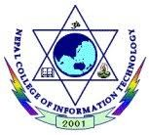**Department of IT Engineering**

**NEPAL COLLEGE OF**

**INFORMATION TECHNOLOGY**

Balkumari, Lalitpur, Nepal

### Abstract

This project implements a Remote Shell Executor using TCP sockets in C++ with the Winsock API. The system allows a client to connect to a remote server over a LAN and send shell commands. The server executes the received commands on the host machine and returns the output to the client. This project demonstrates core networking concepts such as client-server communication, socket programming, command execution, and error handling. The application successfully handles basic shell commands and responds gracefully to invalid inputs or disconnections.

# Introduction

In modern networks, remote access to systems is essential for control, automation, and maintenance. This project aims to create a lightweight remote shell system over TCP where a client can execute commands on a remote server. By using Winsock in C++, the project provides a hands-on understanding of client-server architecture, command processing, and safe communication over a LAN.

## Project Objectives

These are the following objectives of our project, Remote Shell Executor over TCP:

* To allow the client to send shell commands to the server over a TCP connection.
* To enable the server to execute those commands and return the output to the client.

1. **Tools & Platform**

* Language: C++
* API: Winsock
* IDE: Visual Studio
* OS: Windows 11

1. **Key Features**

* TCP socket-based communication
* Shell command execution with output transfer
* Graceful error and disconnection handling
* Optional: multi-client support using threads

1. **System Design**

The project is based on the client-server model:

* Client Side: Connects to the server using a TCP socket and sends shell commands.
* Server Side: Accepts incoming connections, receives commands, executes them using the system shell, and returns the output to the client.

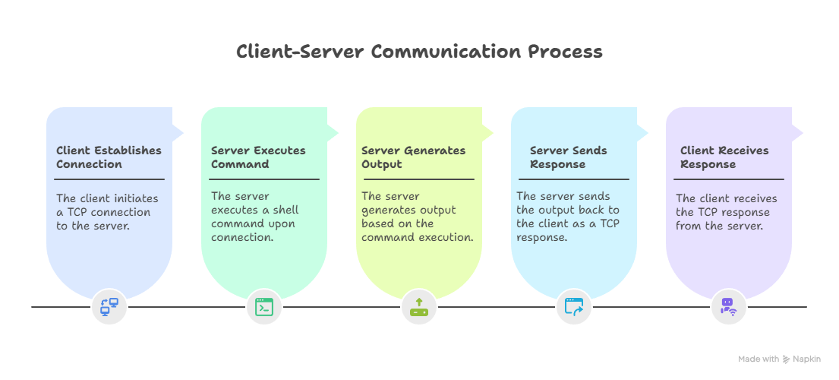

1. **Result and Discussion:**

The application performs as expected, with successful execution of various shell commands remotely. The output is reliably transferred over TCP, and invalid inputs are handled gracefully. The project demonstrates practical knowledge of low-level network programming and command execution.

1. **Conclusion:**  
   The Remote Shell Executor is a focused, educational project that explores core network programming principles through a real-world use case. It highlights TCP communication and system command execution while maintaining simplicity and clarity in design.